Yes. Please Specify: Click or tap here to enter text.

Click or tap here to enter text.

Click or tap here to enter text.

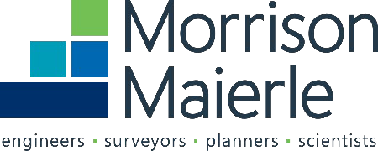

No

Click or tap here to enter text.

Click or tap here to enter text.

Volunteer Hours  
 Other. Please Specify:

3.Type of donation requested**.** Choose one:

Monetary Donation/Sponsorship  
  In-Kind

Donation Request Form Rev. 6/2025

Thank you for your interest in partnering with Morrison-Maierle to build better communities. If your request meets the giving criteria listed on our website, please complete this form and email it to [hello@m-m.net.](mailto:hello@m-m.net) Donation requests are generally reviewed quarterly. If your request is time-sensitive, please let us know your circumstances.

1. Name of requesting organization:

2. Tell us why you are requesting a donation and what it will be used for. Please attach any relevant documentation (brochure, media kit, etc).

4. Amount Requested:

5. Where is your organization and/or event located?

6. Have you communicated with a Morrison-Maierle employee-owner about this request? If so, who?

7. Will Morrison-Maierle be recognized for this donation? Please describe.